**PATIENT II - MEDICAL WEAR WITH INCREASED WEARING COMFORT**

**(Innovation voucher CZ.01.1.02/0.0/0.0/17_115/0011484)**

The aim of the Patient II project is to innovate and test textile products for healthcare and social services with a focus on increased wearing comfort. These innovative textile designs will be used to produce clothing for healthcare staff, linen for patients, including paediatric patients, and bedding. The innovation of the constructions and production of the finished products will be carried out in CLINITEX s.r.o., testing and certification in cooperation with the Textile Testing Institute, s.p. Brno.

Specifically, it involves providing testing and certification of innovative textile products for health and social services with a focus on increased wearing comfort. The products developed will be subjected to verification of compliance with the new

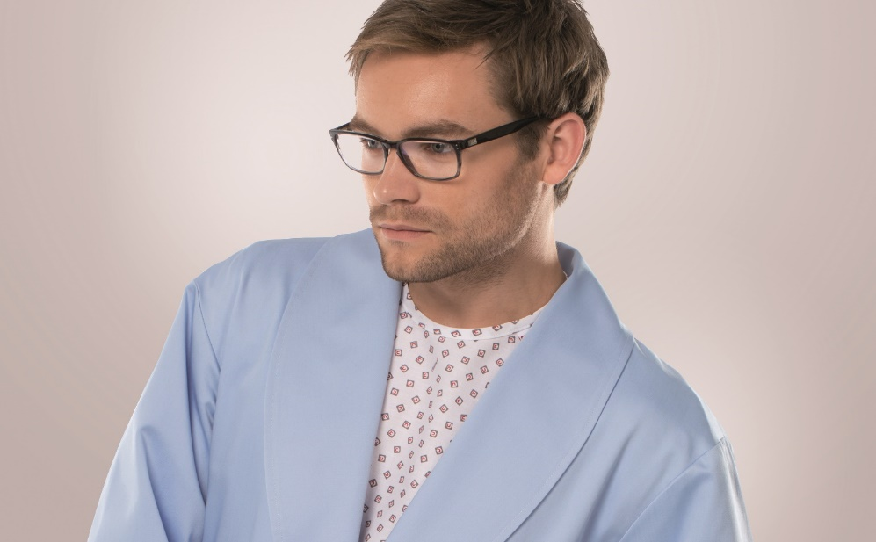ČSN P CEN/TS 14237 Textiles for health and social services and OS 80-07 Textiles for health and social services.

The innovation voucher Patient II - medical underwear with increased wearing comfort (CZ.01.1.02/0.0/0.0/17_115/0011484) was co-financed by the European Union.